Day 15 - 5th July- 113195064 - Bondili Bhavya Charitha
TASK:1 –
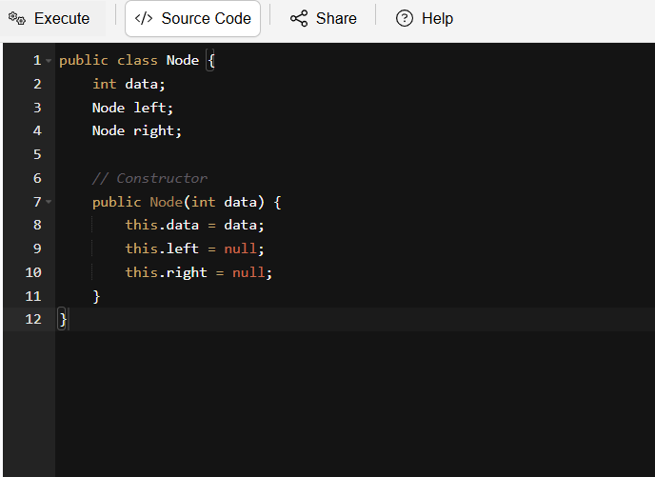

TASK:2 –
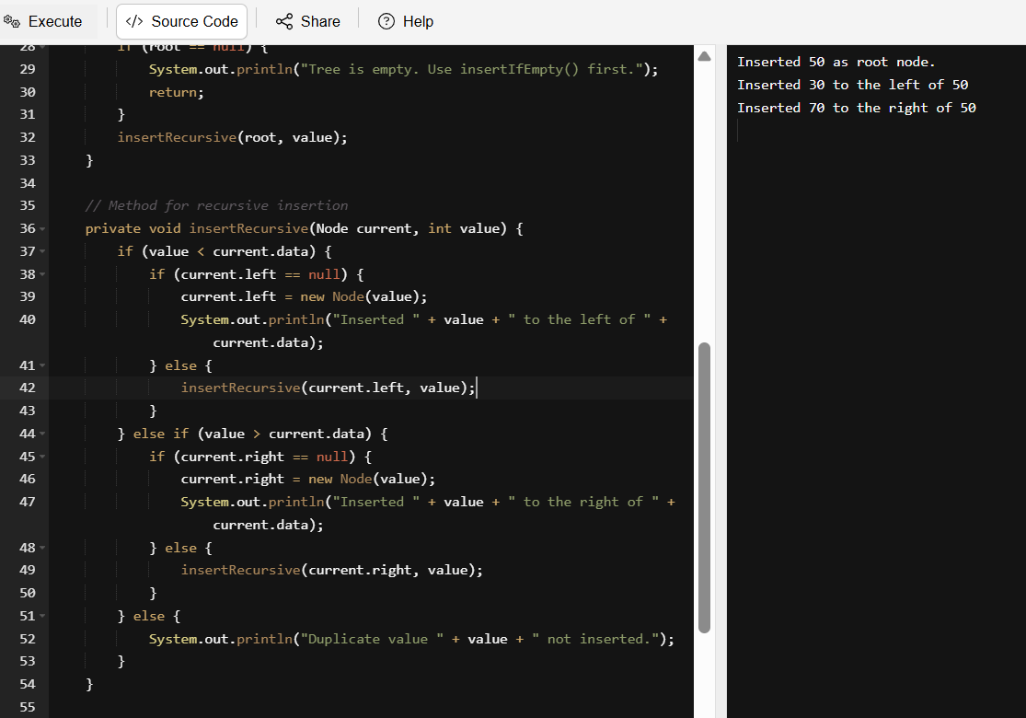

TASK:3 –
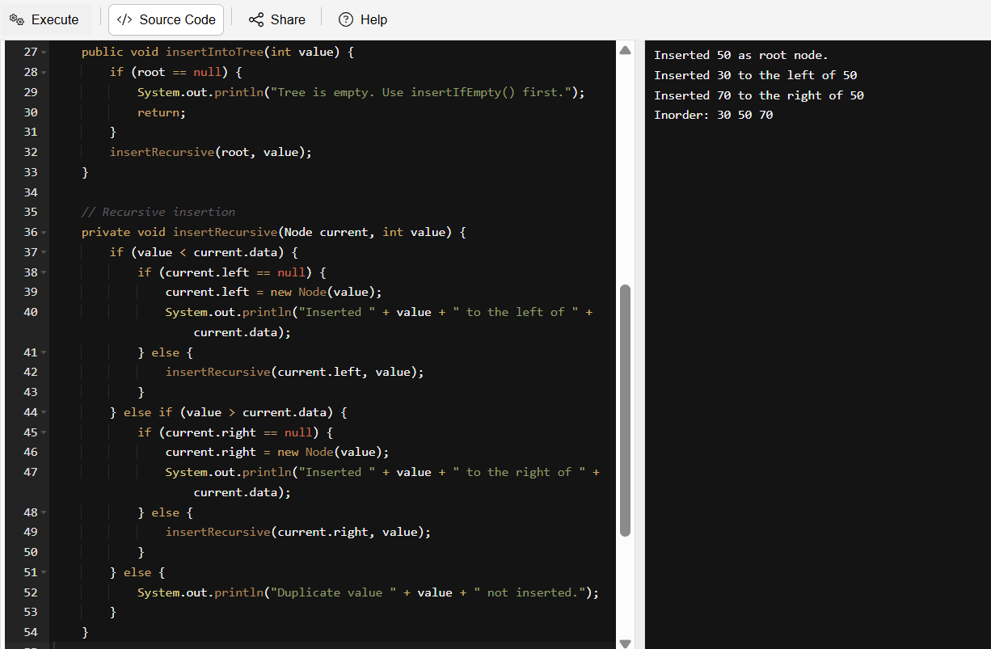

TASK:4 –
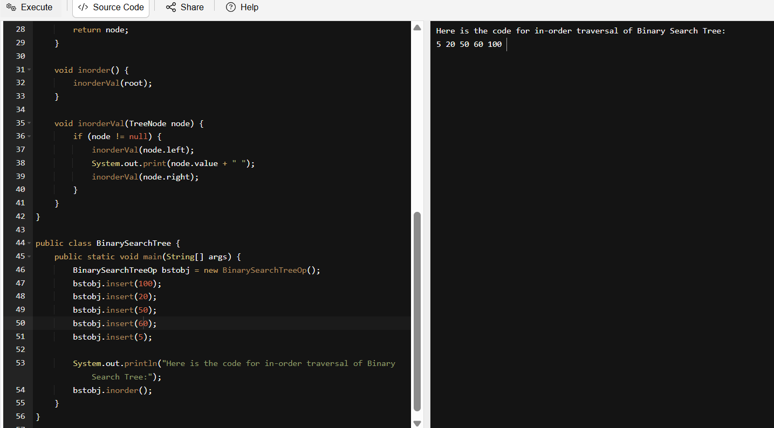
5,20,50,100,400

100

50 400 - 2 Null

20 Taken 20 in place of 70 and taken 100 as root node.

5 – 2 Null
Null 5 null
5 20 Null
Null 400 null
20 50 Null
50 100 400

TASK:5 – Applications of Binary Tree
- Hierarchical Data Representation:
It's used in File systems, organization charts, family trees.
Example: The librarian (My PC OS) uses a binary tree to quickly find where i hid that “_Final_Final_ActualResume.pdf” file.
- Binary Search Trees (BSTs):
It’s used in Fast searching, sorting, and dynamic data storage
- Expression Trees:
It's used in Compilers, calculators, evaluating math expressions
- Huffman Coding Trees:
It's used in Data compression (like ZIP files, JPEGs)
- Routing & Decision Trees:
It's used in AI, machine learning, game logic, decision-making
- Game Trees:
It's used in AI in games like chess, tic-tac-toe
- Parsing & Compiling:
It's used in Programming language interpreters and compilers

TASK:6 – Run the code and tell output.
It is asking the main method should be defined.
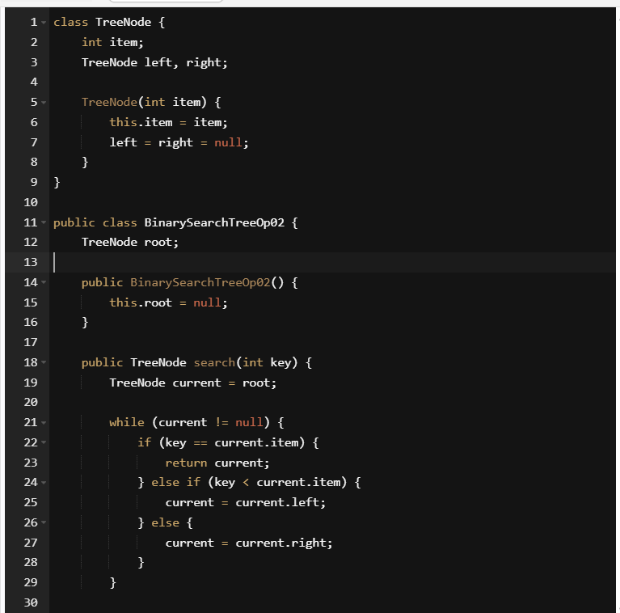
TASK:7 – Types of Binary Trees.
- Full Binary Trees: Every node has 0 or 2 children.
- Perfect Binary Tree: All internal nodes have 2 children (same level)
- Complete Binary Tree: All levels are occupied, except left to right
- Balanced Binary Tree: Height difference between left and right is 1
- Binary Search Tree: Left child < Parent < Right child

TASK:8 – Applications of Graphs
- Directed Graphs are used in Web links, task scheduling, citation networks.
- Undirected Graphs are used in Social networks, road maps.
- Weighted Graphs are used in GPS, airline routes, network routing.
- Unweighted Graphs are used in Friend suggestions, basic connectivity.
- Cyclic/ Acyclic are used in Circular dependencies vs. task ordering.
- Trees (a type of graph) are used in File systems, decision trees.
TASK:9 – Types of Graphs:
- Directed Graphs: Edges have directions (A to B is not equal to B to A). Ex: One Way streets.
- Undirected Graphs: Edges have no direction (A to B equal to B to A). Ex: Like a bestie.
- Weighted Graphs: Each edge has weight. Ex: GMaps showing the destination time. (Travelling time and distance details)
- Unweighted Graphs: All edges are equal. Ex: Subway
- Cyclic: Atleast one cycle included. Ex: Roundabout circles
- Acyclic: No cycles present. Ex: To-do list, where I don’t repeat the completed tasks.
- Trees: Special graph with no cycles and exactly one path between the nodes. Ex: Family Tree
- Complete Graph: Every node is connected to every other node. Ex: Group chating
- Sparse Graph: Few edges which are compared to the number of nodes. Ex: Shy class room where only few people talk like our ATLAS, only few talks.

TASK:10 –
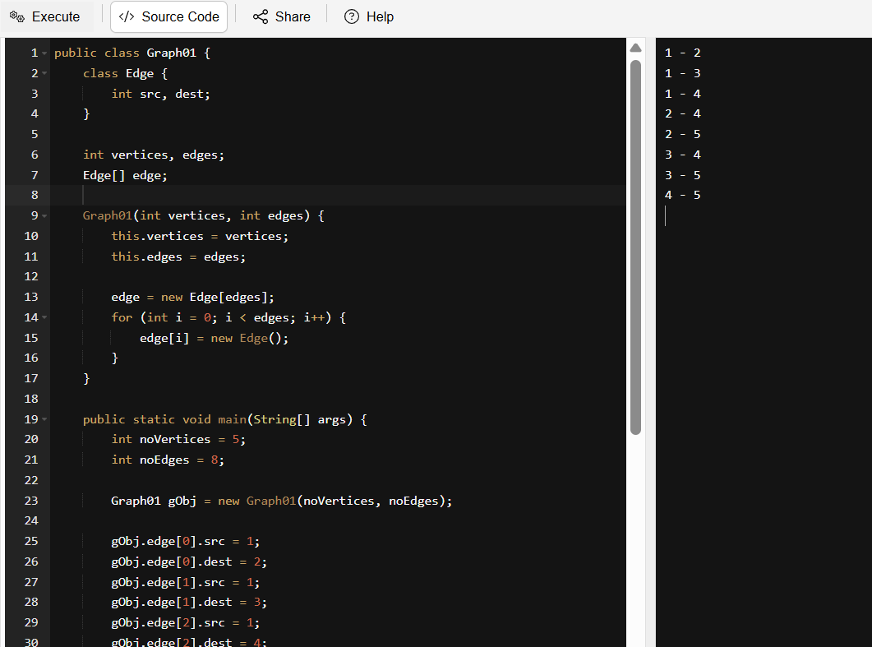
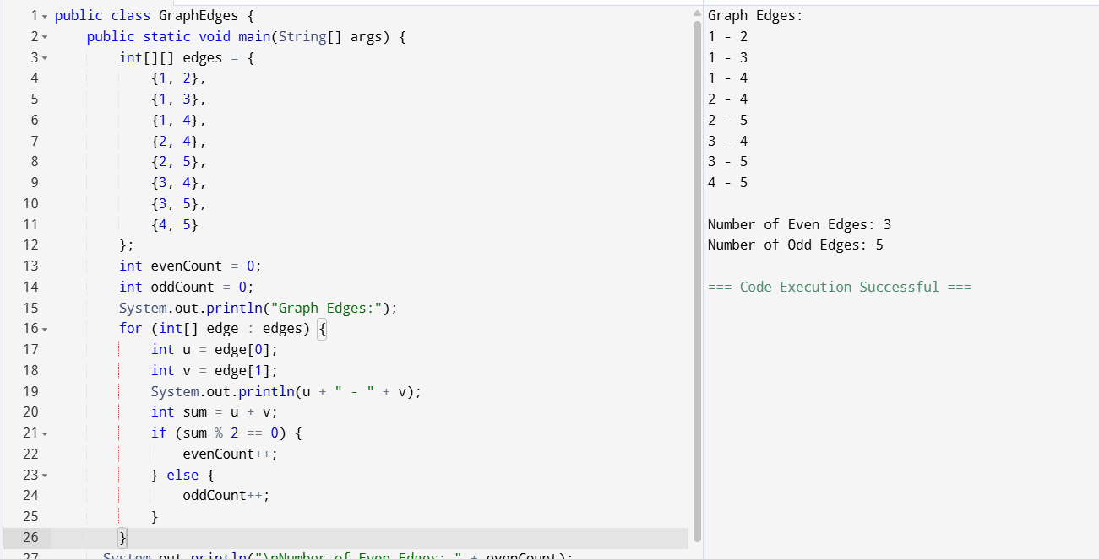
Home Work Tasks:
TASK:1 – Wap to find the factorial of a number.
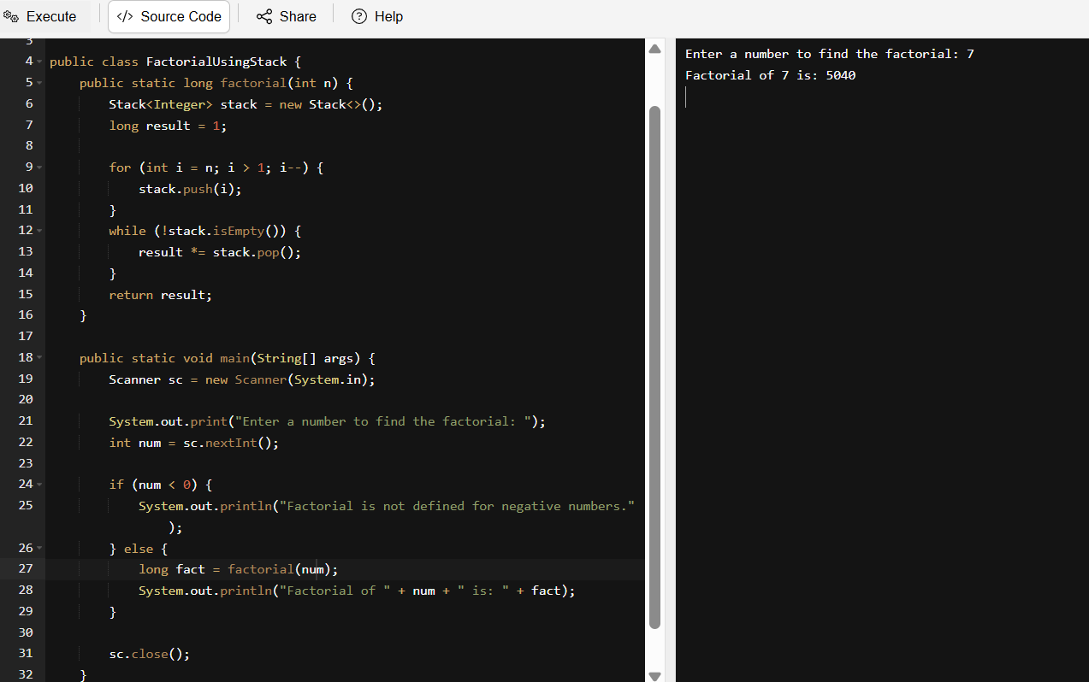

TASK:2 - Wap to find the Fibonacci series of a number
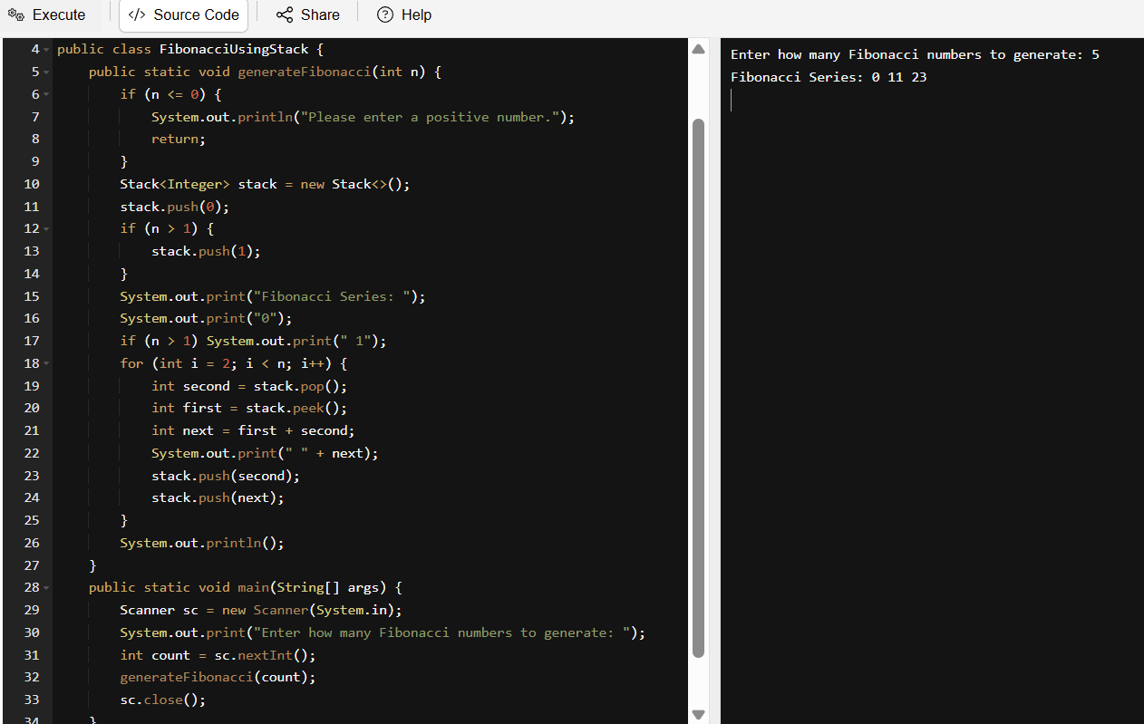
TASK:3 - What is the difference between recursion and iteration.
Recursion: A function calls itself to solves a smaller sub problem. It uses call stack. Performance can be slower due to the overhead of the function cells. It is more elegant and readable for the problems like tree traversal or factorial. It has minimal risk when stack overflow’s base case is missing.
Iteration: A set of instructions is repeated using loops (While,For). When loop condition becomes false, it will automatically terminate. It uses loop variables. It is generally faster and more efficient. It will have to face risk when infinite loop if condition is incorrect.

TASK:4 - Wap to reverse a string using recursion.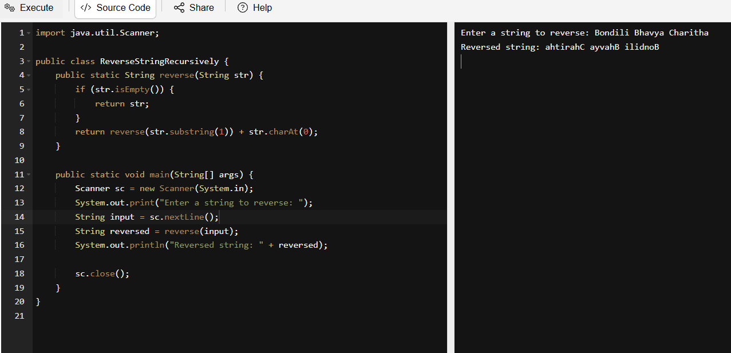

Carry forward examples till 11th July:
- Write a recursive function to search for an element in an array.
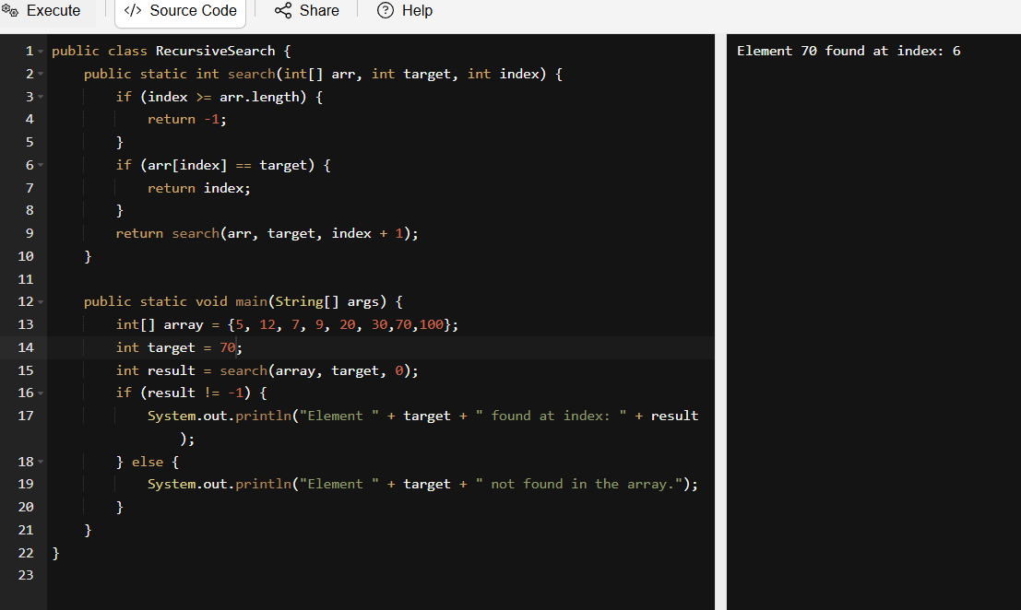

- Write a recursive function to count the digits of a positive integer (do also for sum of digits).
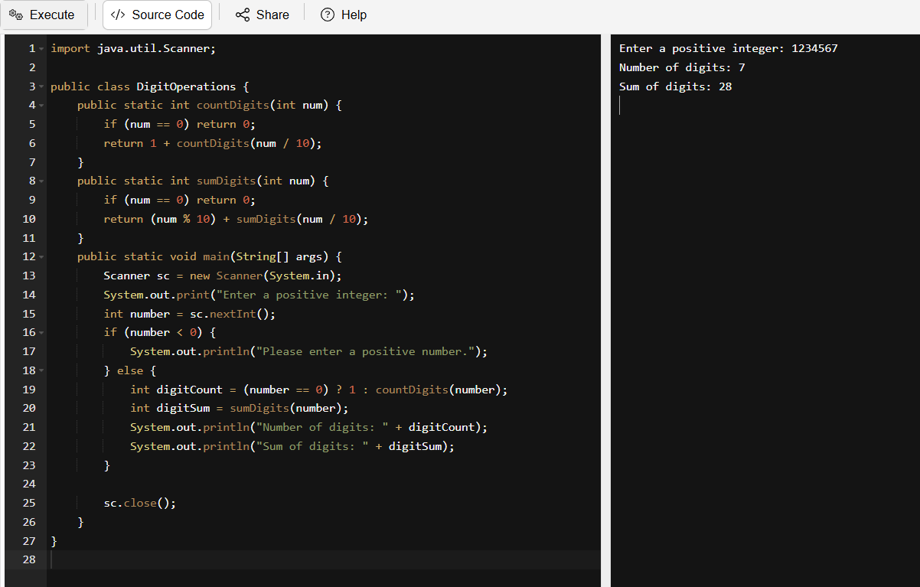

- Write a recursive function to reverse a null-terminated string.
In Java, strings are not null-terminated like in C, but we can simulate this by treating the end of the string (i.e., when the index reaches the last character) as the base case.
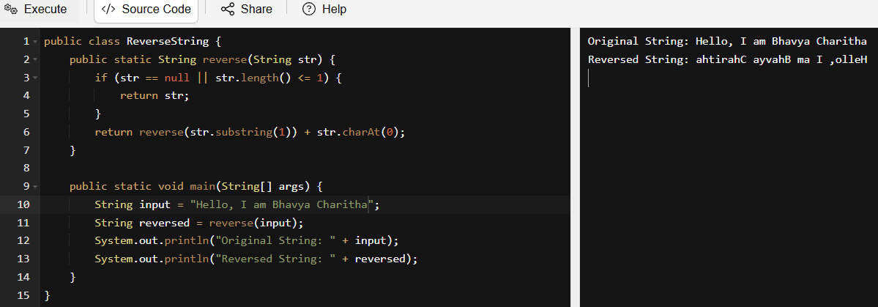
- Write a recursive function to convert a decimal number to binary.
